**Hello Ben  
  
We have dig more on the APIs today and we have several points to let you know, please check:**

1. Does the 510k listing show the manufacturer of the product?

**Comment**: Yes we see the manufacturer in the response.   
API:

https://api.fda.gov/device/registrationlisting.json?search=establishment_type:Manufacturer&limit=10

Screenshort:

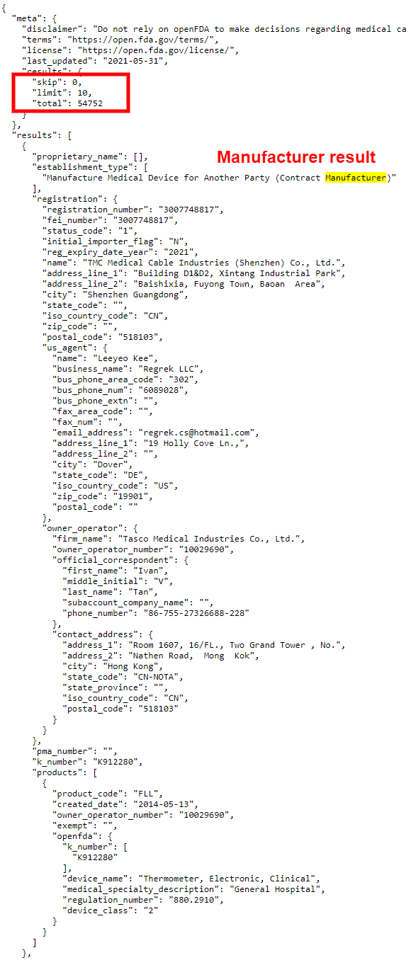

2. Also-does it provide their U.S. agent contact information?

**Response** : US_AGENT almost the same US

**However, certain contact addresses and owner operator addresses are not the same.**

Screenshot:

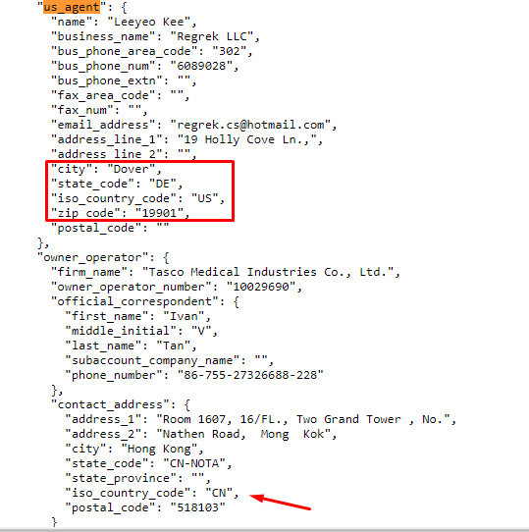

1. I believe there is another database with a list of Medical Device manufacturers. I was hoping we could gather both and link the suppliers to their products. This database here seems to be the manufacturer database with device listings also.

**Response** : Each api has a unique response, and each response is linked to another api, such as find the url and analyze the response.

Below api have different response

Step 1. For Product Code

URL : <https://api.fda.gov/device/registrationlisting.json?count=products.product_code>

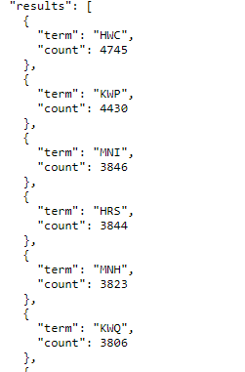

2. Step 2. For product lists

URL : <https://api.fda.gov/device/registrationlisting.json?search=products.product_code:HWC>

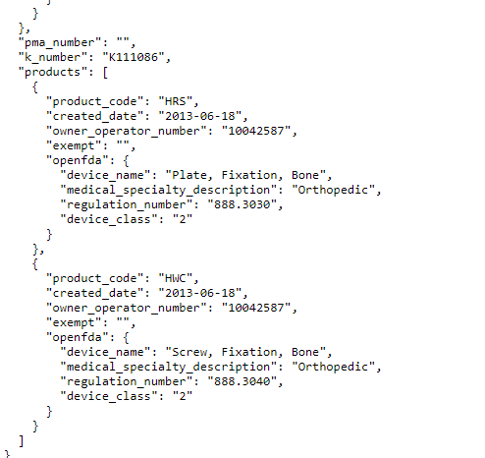

**Queries :**

**Please hit the below APIs and send me some required information because we do not have much knowledge about medical devices.**

1. https://api.fda.gov/device/registrationlisting.json?search=products.product_code:HQY
2. https://api.fda.gov/device/registrationlisting.json?count=proprietary_name.exact
3. <https://api.fda.gov/device/registrationlisting.json?search=products.product_code:HQY&count=proprietary_name.exact>

**Problems:**

1. **These api have no paginations so we could not find the total record of data like how many devices.**
2. **We are not seeing any image in the response. Need to see how we can get the images of the devices.**